- Write a program that prints out a list of the integers from 1 to20 and their squares.
- Write a program that uses a for loop to print the numbers 8, 11, 14, 17, 20, ..., 83, 86, 89.
- Write a program that uses a for loop to print the numbers 100, 98, 96, ..., 4, 2.
- Use a for loop to print an upside-down triangle like the one below. Allow the user to specify how high the triangle should be.
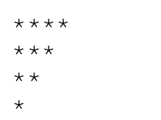
- Use for loops to print a diamond like the one below. Allow the user to specify how high the diamond should be.
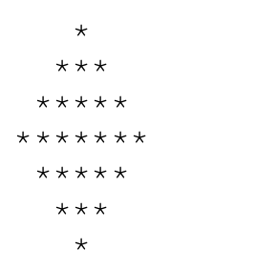
- Write a Python program that takes a user input (positive integer). The program should then iterate through numbers from 1 to that number (both inclusive) and print "tik" if the current number is divisible by 3; otherwise, it should print "tok".

Question1:
Compute the perimeter of a polygon.
Instructions:
- Write user defined function to find the distance between the points A(x1, y1) and B(x2, y2).
- Write user defined function with input argument as a list (of coordinates of points of the polygon),
such that, this user defined function calculates the perimeter of the polygon.

Question 2: Write a user defined function to sum of the squares of whole numbers upto "n".
Instructions:
- Use while statement to print the cumulative total
- Also print the grand total

#Q3: Write a Python code to find the factorial of the given number
#Instruction:
#Write a user defined function with 1 input parameter

#Q4: Write a Python Program to reverse the given number.
#Instrutions:
#Write a user defined function with 1 input parameter.

